‘UVINJE EVICTION SAGA’

LHRC FACT-FINDING MISSION REPORT, IN SAADANI NATIONAL PARK
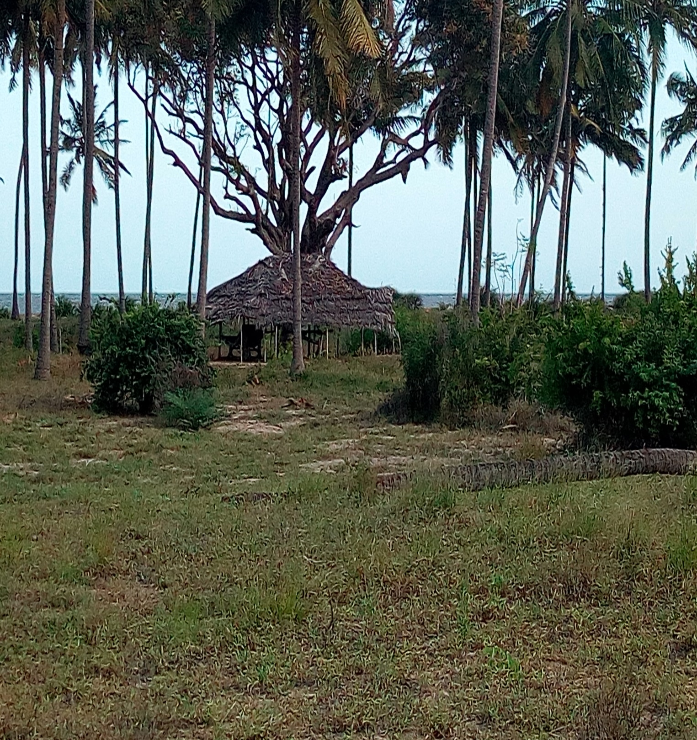

OCTOBER 4, 2017
TABLE OF CONTENTS
- INTRODUCTION
- MISSION’S METHODOLOGY
- Desk review
- Interview
- Observation
- BRIEF BACKGROUND OF THE ‘UVINJE’ SUB-VILLAGE
- ESTABLISHMENT OF THE SAADANI GAME RESERVE TO NATIONAL PARK
- REASONS BEHIND THE EVICTION OF UVINJE RESIDENTS
- CURRENT LIVING SITUATION OF THE UVINJE RESIDENTS
- RELATIONSHIP BETWEEN THE UVINJE SUB-VILLAGE AND CONCERNED GOVERNMENT AUTHORITIES
- GENERAL OPINION AND RECOMMENDATION OF THE UVINJE RESIDENTS
- CONCLUSION

  - INTRODUCTION
This is a report of the fact-finding mission conducted on 4th October, 2017 by the Legal and Human Rights Centre (LHRC) at UVINJE sub-village, SAADANI Village, CHALINZE District in PWANI region (Tanzania) whereas the residents of UVINJE sub-village were forced to evacuate from the place giving room for expansion of the national park (Saadani National Park -SNP). The dispute started since 2001 whereas formal talks between the government officials and authorities (including the District Commissioners, Regional Commissioners, Ministerial officers, TANAPA and other government senior staffs) and the villagers of the UVINJE sub-village were conducted concerning the ownership of the particular land in dispute however there was no final resolution which reached a consensus between the parties.

In February 2016, the UVINJE Villager approached the Commission for Human Rights and Good Governance (CHRAGG) to help resolve the dispute whereas in May 2017, CHRAGG ruled in favour of the UVINJE villagers as it stated that:
‘Uvinje hamlet has never been part of the Saadani Game Reserve, therefore its inclusion within the boundaries [sic] of National Park is unlawful and contrary to the Constitution of the United Republic of Tanzania…’
In August and September 2017, a committee formed of representatives from TANAPA, the Ministry of Natural Resources and Tourism, and other government authorities carried out their own investigation into this land rights issue. This committee found in favour of TANAPA’s ownership of the land and declared that the UVINJE villagers must vacate their village within 28 days.
With regard to unanswered cry of the UVINJE residents, Protimos has requested LHRC to conducted a fact-finding mission in the sub-village and extract essential information which will be useful in briefing the group of interested international charities about what is happening in UVINJE and how the situation can be resolved if assistance is provided. Among the things LHRC needed to extract from UVINJE were; how the villagers have fared during the dispute, taking photographs of the village, the wellbeing of the village, the relationship of the village and the concerned government authorities such as TANAPA as well as general opinion of the villagers about the case in hand.
  - MISSION’S METHODOLOGY
In facilitating the implementation of this fact-finding mission, LHRC conducted:
Desk review
Various available literatures concerning the dispute of UVINJE sub-village and the TANAPA were accessed and reviewed in order to collect the information with regards to the land dispute and which steps have already been taken to date, in attempting to resolve the problem. Acknowledgements are dedicated to ICCA CONSORTIUM, an organization which has tried in large extent to research and document records of the UVINJE dispute since the origination of the Saadani Game Reserve in 1968 to the establishment of the National Park in 2005 and all attempts involved in settling the disputed.
From their documents LHRC found out that ; the Wildlife Conservation Game Reserves Order, Section 8, Official Gazette, G.N. No. 275 of 1974 which gives details of the boundaries of the SGR, the spatial analysis on extent and location of Saadani village’s land gazette as park land. Also LHRC found that the pre and post Park establishment official communications, from District and Village level authorities, addressing multiple issues relating to Park claims to village land.
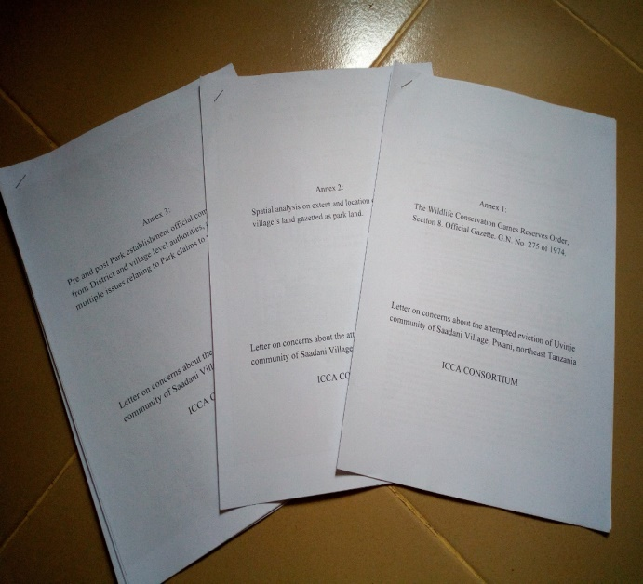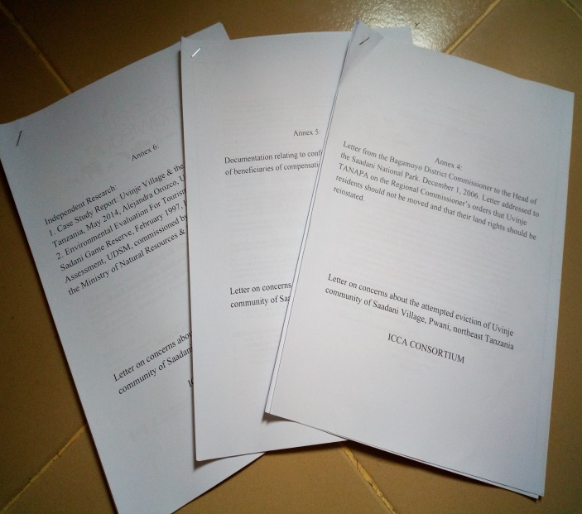
Figure 1: ICCA CONSORTIUM Materials used to get familiar with various details about the Uvinje sub-village conflict with TANAPA

The attached independent researches in ‘Annex 6’ which were conducted by Alejandra Orozco, University of Victoria on: Uvinje Village and the Saadani National Park Tanzania (May, 2014)’ and that one of Institute of Resource Assessment (UDSM), commissioned by the Wildlife Division and the Ministry of Natural resources & Tourism researching on: Environmental Evaluation For Tourism Development in Saadani Game Reserve, (February 1997) have significance role in clearly getting understand of the Saadan-Uvinje dispute and demarcations of the truly unobserved boundaries by the TANAPA.
Whereas in these details, it is interesting to note that, there is a letter written by the Bagamoyo District Commissioner, Hon. Hawa S. Ngulume (retired) to Director General of TANAPA on 12th March 2005 which addressed in particular ‘the ambiguousness of the compensation alleged to be paid by the TANAPA to the villagers of UVINJE sub-village’, ‘the modality of payment which is said to be paid at night while there was no reason to hurry-up’ as well as ‘’Regional Commissioner speech of 23/08/2001 in the public meeting who directed that the boundary of the SGR project is to end at the river and not beyond into Makurunge village. Also Annex 4 of ICCA CONSORTIUM details about the letter written on 1st December 2006 by the Bagamoyo District Commissioner Hon. Lt. Col. (rtd) S.M. Mrengo to the Director of the SANAPA which was titled ‘’implementation of the provincial commissioner’s recommendations during his visit to the villages neighbouring SANAPA’ whereas the Regional Commissioner ordered that ‘Uvinje residents should not be moved and that their land rights should be reinstated’
- Interview
Interview was dominant data collection method in this fact-finding mission whereas the LHRC collected primary information from the targeted victims of the eviction in Uvinje sub-village structured and unstructured way.
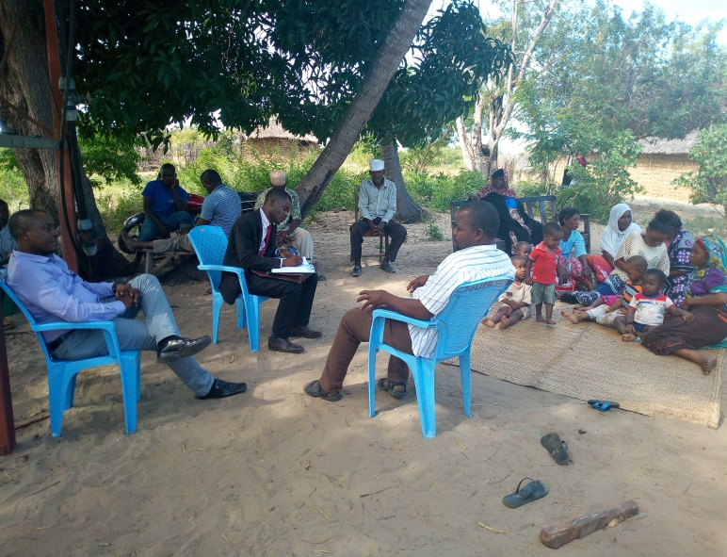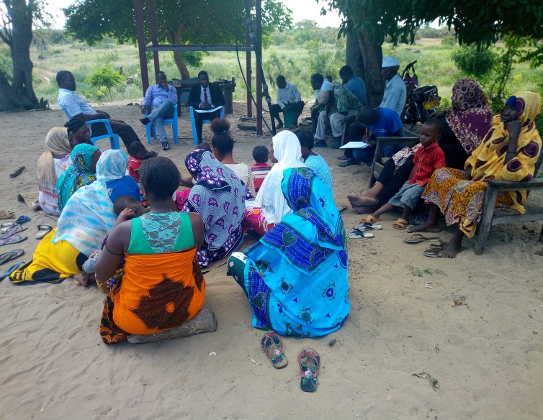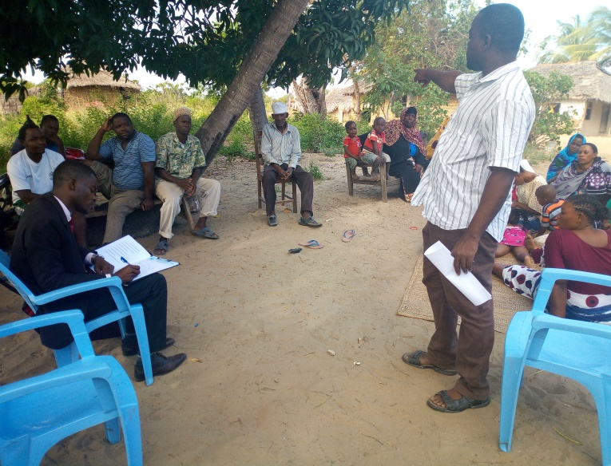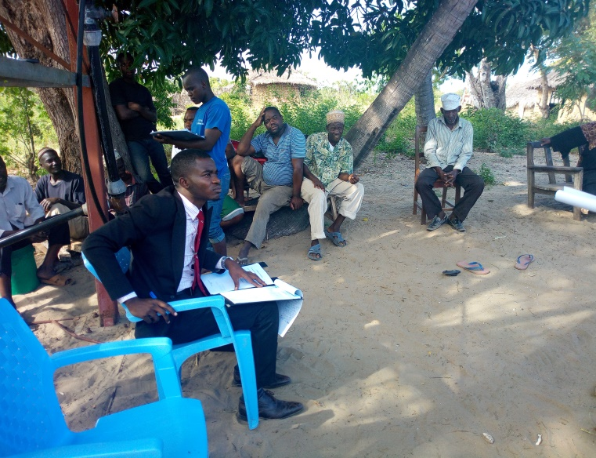
Figure 2: Mr. Ally Seif Ramadhani (LHRC) conducting interview with the Uvinje resident in Saadani Village
- Observation
The LHRC used an observation method so that to get visual information of the Uvinje sub-village during and after the interview session whereas it managed to visit and investigate various places, buildings and other assets of the Uvinje sub-village.
  - BRIEF BACKGROUND OF THE ‘UVINJE’ SUB-VILLAGE
During the interview session with almost all the present villagers of the Uvinje sub-village, the LHRC noted that, there is no clear record of when did the sub-village emerge but history dates it back before the colonial era where people were living and associate their socio-economic activities with this sub-village. It is also unknown to which village is within the other between Saadani and Uvinje since both villages were present during the beginning of the First World War (1914) though currently Uvinje is a sub-village of Saadani village, adjacent to the Saadani National Park, approximately eight (8) km from Saadani Village. There are descendant people who had lived in this sub-village for more than a hundred years and buried here before the coming of neither the SGR nor the SANAPA.
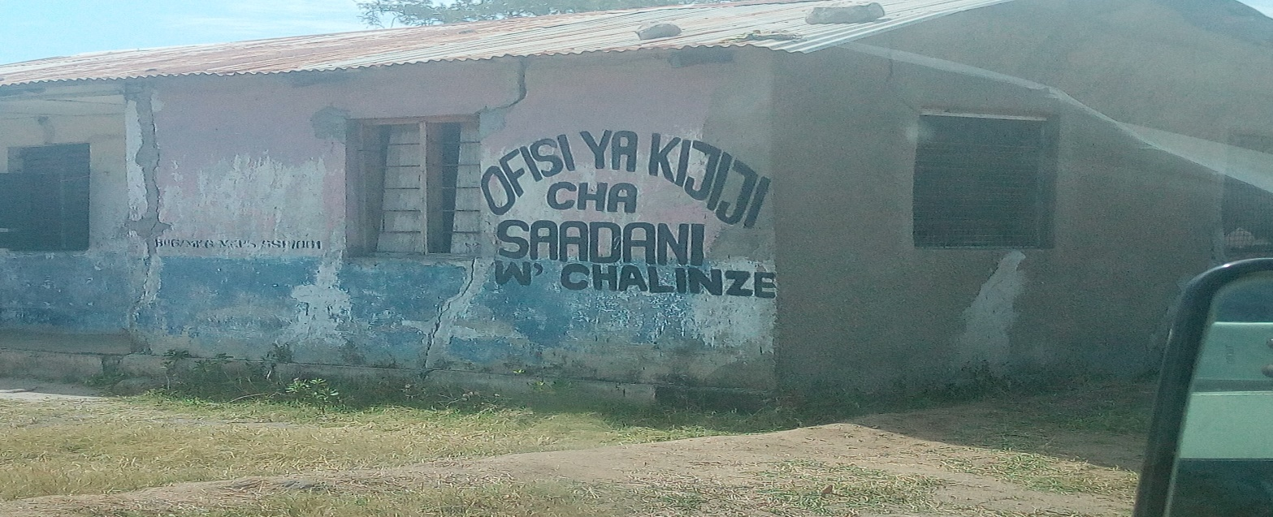
Figure 3: The Local Government office of the Saadani Village. The photo was taken during the arrival of the LHRC in Uvinje sub-village, Saadani Village, Chalinze District in Pwani region

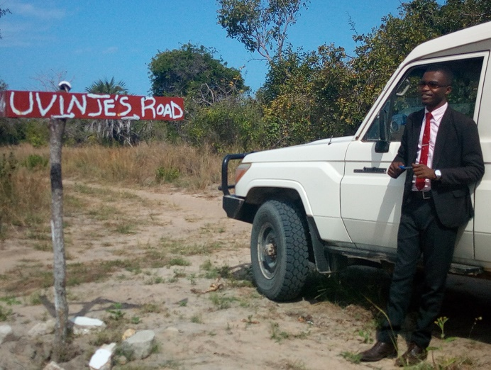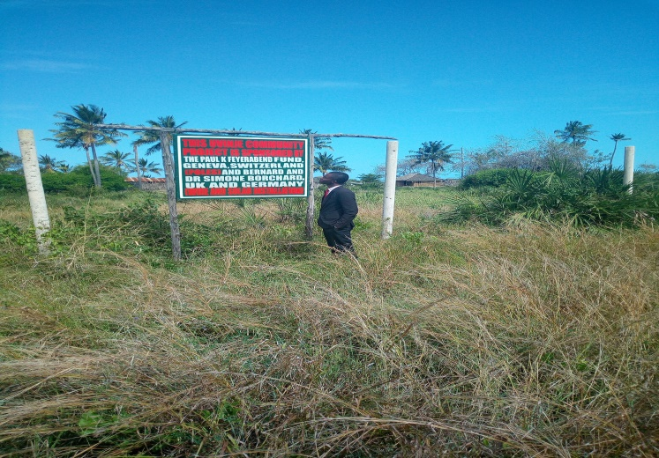
Figure 4: The Junction to Uvinje Sub-Village (left) The Elephant Protection boundary Project Mark (Right)
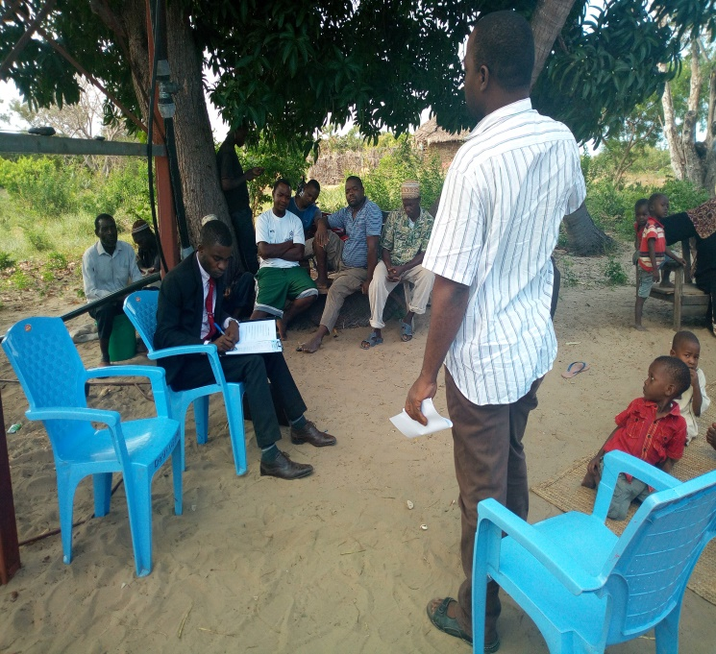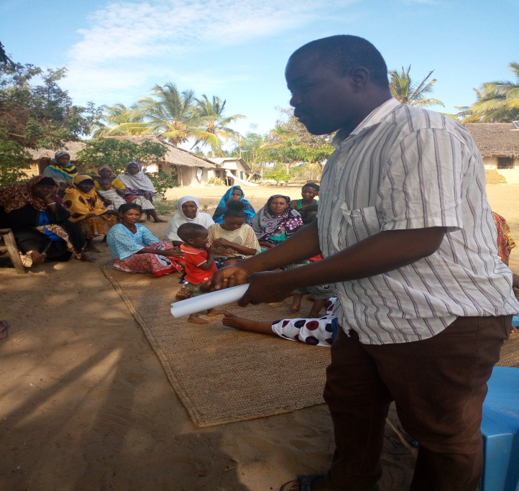
Figure 5: Mr. Hussein Salehe Akida (left and right), Chairperson of the Uvinje sub-village who was sharing his views during the interview session
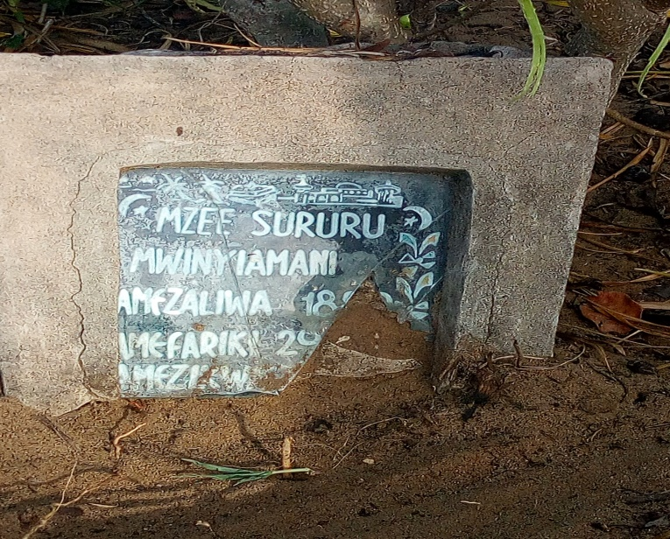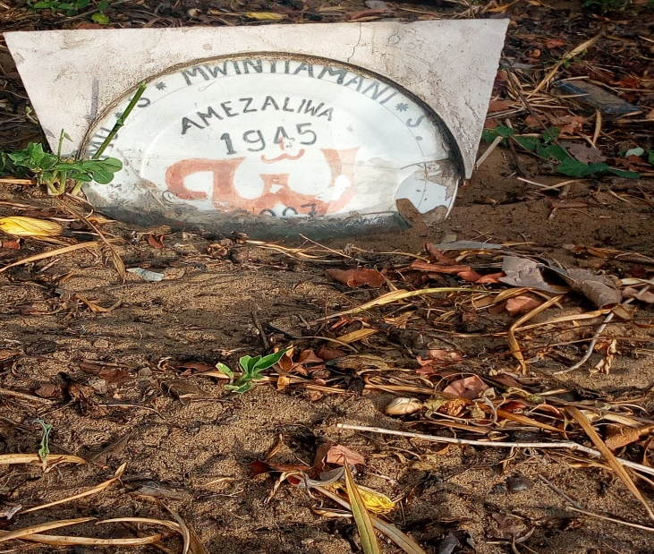
Figure 6: Tombs of the oldest descendants of the Uvinje sub-village who were born in the village before the British colonialism and other before the Independence of Tanganyika (left tomb, he was born in 1896 on right he was born in 1945)

The Uvinje sub-village is said to be 3000 acres since the ancestral era. During ancestral era before the partition of their lands, Uvinje, Saadani and Kajanjo villages were called Utondwe. Currently it has about eighty eight (88) residents, twenty three (23) households, whereas the number of the residents includes women, men, youth and children but noted that women are majority of the population as they constitute of fifty five (55) of the eighty eight (88) residents. General assumption of all descendants from Uvinje sub-village who are found in other places outside the area is more than four hundred (400) people.
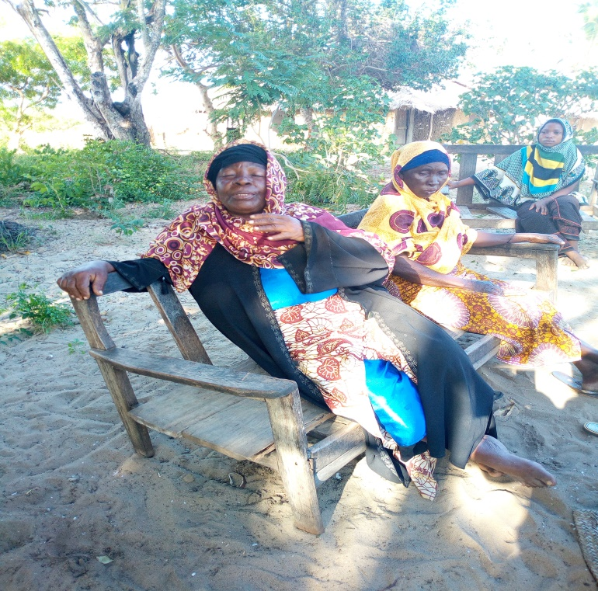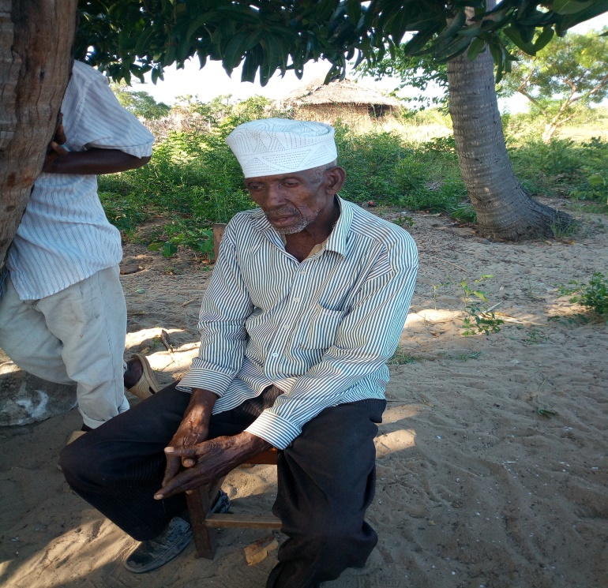
Figure 7: The oldest residents of the Uvinje Sub-village who knows very well historically about the establishment of SDG and SANAPA who were used to live Uvinje before Independence.
Major economic activities conducted in this area are including; fishery and fishmonger, handcrafting activities, agriculture for commercial and substance crops, cattle grazing as well as traditional salt making.
  - ESTABLISHEMENT OF THE SAADANI GAME RESERVE TO NATIONAL PARK
The Saadani Game Reserve (SDG) has been established from the personal initiatives of the villagers of the Saadan village in early 1960’s, while Saadani villagers were involved in collective decision-making and other institutional activities at the village Centre, they received the unexpected visit of the then Director of Wildlife, Mr. H.S. Mahinda, who was passing by on his way to Tanga. After learning who he was, Saadani villages leaders approached him to request support to protect the wildlife that was being indiscriminately killed by outsiders. The leaders’ bold step led to the establishment of the first conservation venture in Saadani, the Saadani Game Reserve.

As such, the proposed Saadani Game Reserve (SGR) became operational before the 1970s and was officially gazetted in 1974. Hon. Mfaume Kawawa, the late (retired Prime Minister) launched the reserve. Some people were removed from few sub-villages such as Gogo-Diola and brought to Uvinje as way of contributing to the establishment of the reserve. Managed by the Wildlife Division Department (WDD) over the next three decades, the reserve became of interests to the Tanzania National Park Conservation Agency (TANAPA) as a unique prospective place for a coastal national park in the 1990s, which led to TANAPA intervening in the drawing of a SGR map, and to the subsequent establishment of the Saadani National Park (which included the reserve) in 2004.
  - REASONS BEHIND THE EVICTION OF UVINJE RESIDENTS
From the interview conducted, people mentioned the following as the reasons for their alleged eviction as commanded by the government through its officials and authorities:
    - Uvinje sub-village is within the Saadani National Park boundaries and even during the SDG it was within the boundaries of the game reserve.
    - Uvinje sub-village has no school where they would be sending their children to get education.
    - Uvinje sub-village has no hospital for medication where their health would be deteriorated.
    - Uvinje sub-village has no clean and safe water for drinking and domestic use thus their health are in danger for them to live in such place.
    - Wild animals are in the increasing trend thus threatening the security of the Uvinje villagers.
All the factors or reasons mentioned above lack proof from the contextual analysis of the said area (Uvinje). The reasons given are governmental based with poor logic of their standing as when we refer first reason it departs from all facts existing before which established SDG which had never included Uvinje in its boundaries. But the fact that Uvinje is in the Park boundaries fail to be maintained with regarding to the years of the Uvinje existence and the Park which was established recently in 2005.
Also, for the fact that Uvinje has no school, hospital, or clean and safe water, it is clearly indicating that, the government has forgotten its primary responsibility to its citizens as provided in the constitution under Article 8 (1) (b) which entails that; ‘the primary objective of the Government shall be the welfare of the People.’ That means government is accountable to the people for their welfare and that’s including provision of basic services such as water, schools, hospitals, security, and many other things. The concern of increasing number of wild animals who are threatening wellbeing of the people is not true as it has never been reported by the villagers or by the TANAPA and other concerned government entities that wild animals have attacked and killed resident particularly from Uvinje. It has not been known why to the government authorities the fear of attack from wild animals is higher than the courage to reshape and modify the area for the wellbeing of the people.
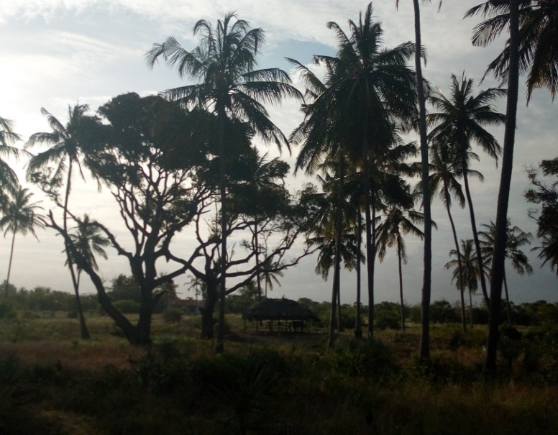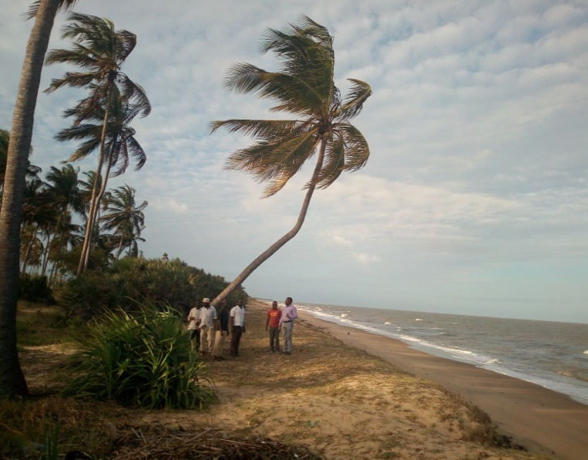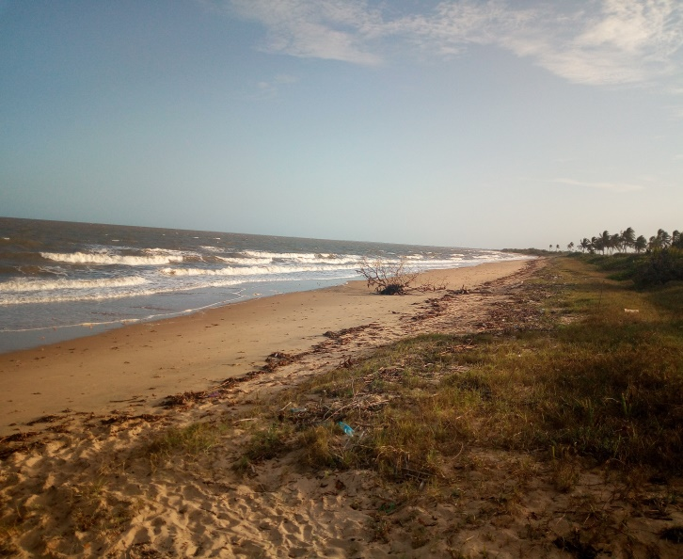
Figure 8: Beautiful scenery of Uvinje shore which is very attractive for tourism activities
  - CURRENT LIVING SITUATION OF THE UVINJE RESIDENTS
Currently residents of Uvinje sub-village are living in fear and tension of being invaded and maliciously being treated by the government and its agencies because of the land in dispute. To Uvinje villagers, the Uvinje land is an ancient asset that they have inherited form the grandfathers of their grandfathers therefore they are ready to die defending their very precious asset. On the government side, the Uvinje land is very wanted by any means necessary for illogical spelled reasons but behind them for investment purposes.
The compensation which has been said to be paid to some Uvinje residents is a fabrication that no one among the Uvinje residents had ever received or accepted to be paid as compensation to get out of the area. The question posed by the Uvinje villagers on ground of compensation by the government is that; If at first place they are offenders for invading and dwelling within the boundaries of the Game Reserve which then after became a National Park (Saadani), why the government insists to compensate the criminals? Is that they way being done for murderers in murder case when being found guilty are paid compensation for rectifying the scenario?
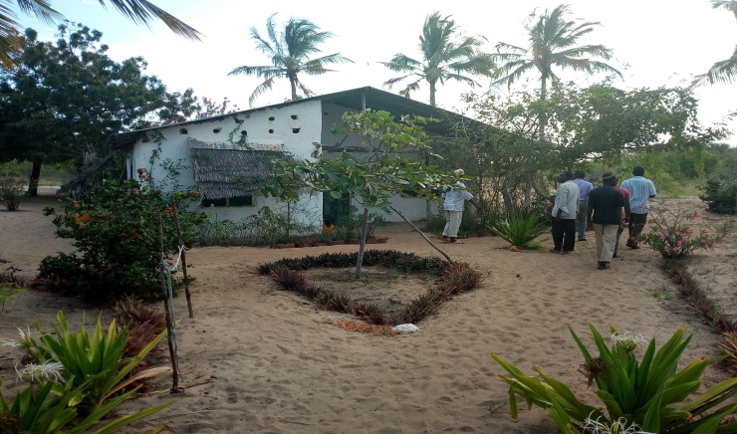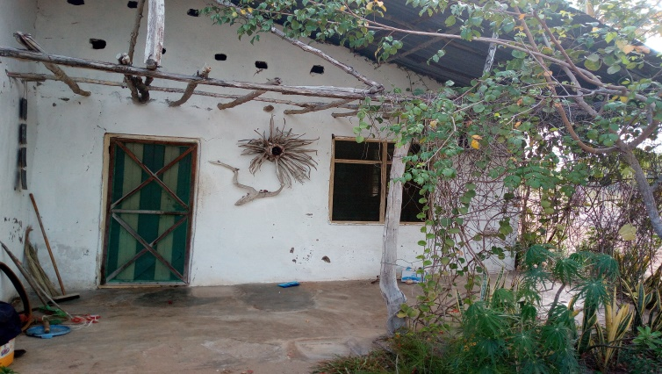
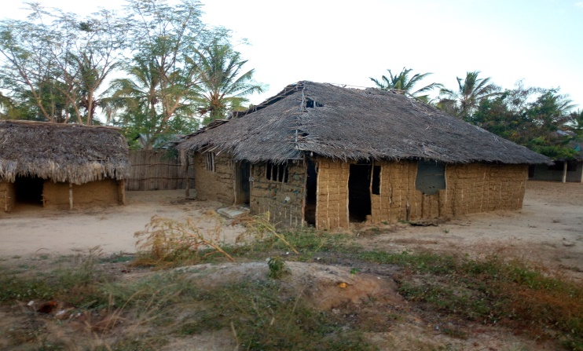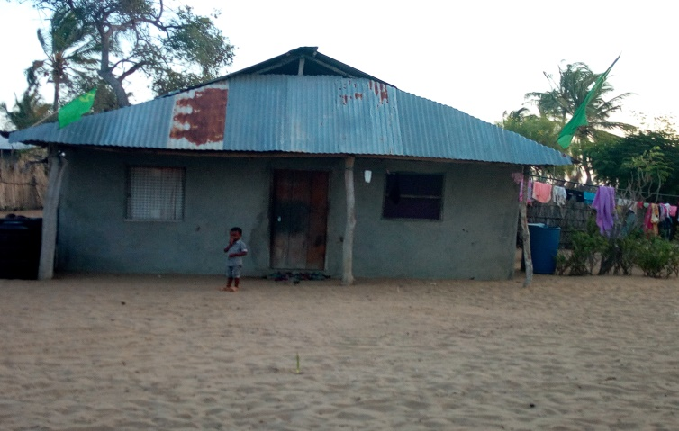
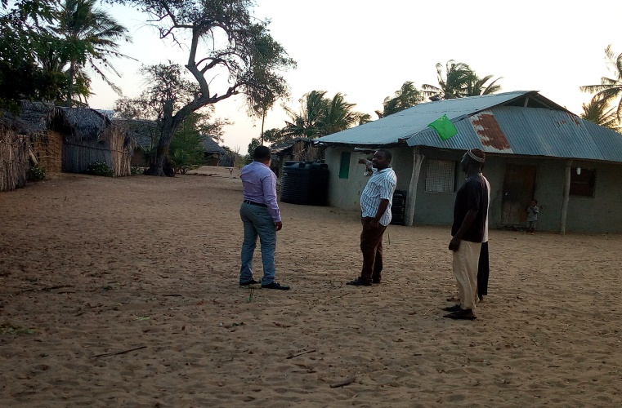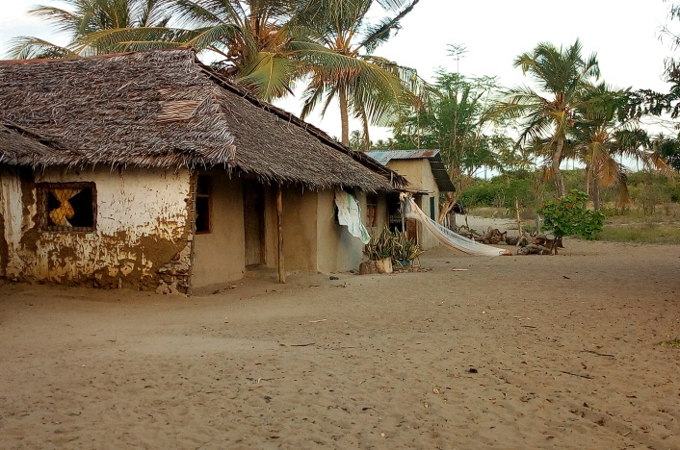
Figure 9: various building premises of the Uvinje villagers which are used for living

  - RELATIONSHIP BETWEEN THE UVINJE SUB-VILLAGE AND CONCERNED GOVERNMENT AUTHORITIES
Currently there is no good relationship between the Uvinje villagers and the TANAPA as well as other government officials and authorities concerned with the dispute. It has been noted that, even those people who were engaging with SANAPA in tourism activities who are originating from Uvinje have been removed from service or have been indirectly not engaged in various tourism activities of SANAPA regardless of the knowledge in tour guiding or the animal species.
  - GENERAL OPINION AND RECOMMENDATION OF THE UVINJE RESIDENTS
The Uvinje villagers (residents) have general opinioned that the motive behind their commanded eviction is the corruption for investment purposes that the SANAPA and TANAPA corrupting government officials especially in district level to use unnecessary force and power to order eviction of the Uvinje villagers so that to pave the way for new investment which will give them lucrative return in terms of economic scope.

Generally the case is very simple as numerous written documents are existing which can prove innocence of the Uvinje sub-village out of the re-drawn maps of National Park. The Uvinje residents pray for the government and its authorities to respect the original boundaries of the Park and the sub-village. The use of district government and regional government (officials i.e. D.C and R.C) who are mostly used to supply sarcastic and threatening words to the people of Uvinje so that to force them evacuate the place will never provide long last solution.

The Uvinje community believes that through aid and assistance from outside the place by the good wishing people and institutions will help them to get liberty of their place because their opponents are powerful economically, politically and military forces.

The people of Uvinje sub-village have no interest to accept any compensation for granting their land. The people are ready to be forsaken by the government, to live underprivileged lives, to fight for their basic social services, but not to move out of their ancient land of Uvinje.

If the eviction will be successfully as commanded by the government, the people of Uvinje sub-village will be losing the following asset which they have strived for a very long time to acquire and maintain such as; their established Saccos and Coco Lodge Company, bricks factory and warehouse, more than twenty six (26) which withhold about eighty eight people (88), their farms for permanent and temporary crops (coconuts, millets, maize), cattle (goats, cows, chickens, dogs, cats,) their fishing boats and fishing nets, salts deserts, motorcycles and bicycles, water tanks, their initialized assets for the elephants protection project.
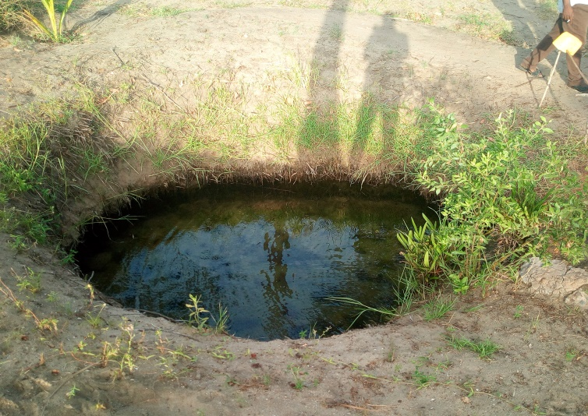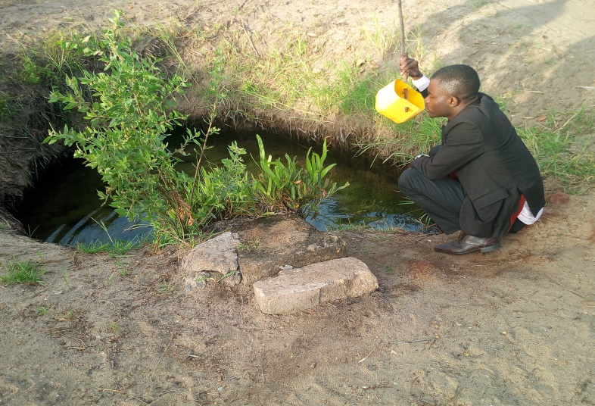
Figure 10: The oldest natural well situated at Uvinje sub-village whereas it feeds more than three villages. It provides fresh water which are used for all kinds of domestic purposes
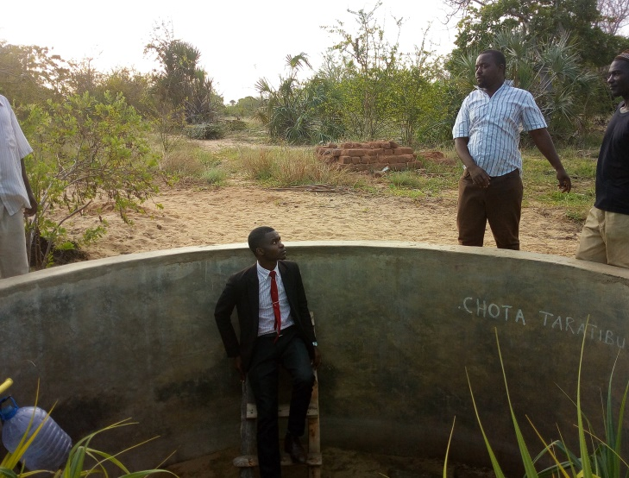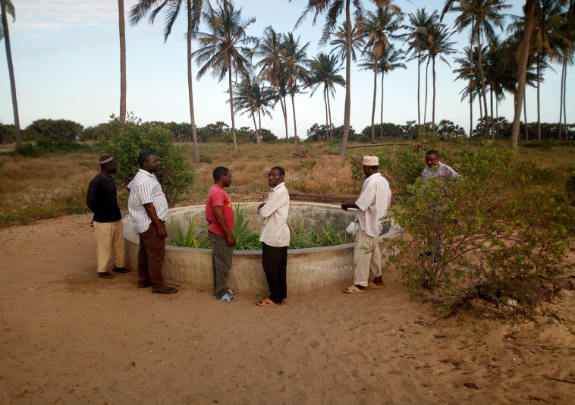
Figure 11: Man Made ‘Well-spring' at Uvinje whereas cool fresh water for drinking are fetched here.
Inspection of assets and natural resources of Uvinje sub-village went on whereas we reached to the bricks factory and warehouse of the village as shown herein below;
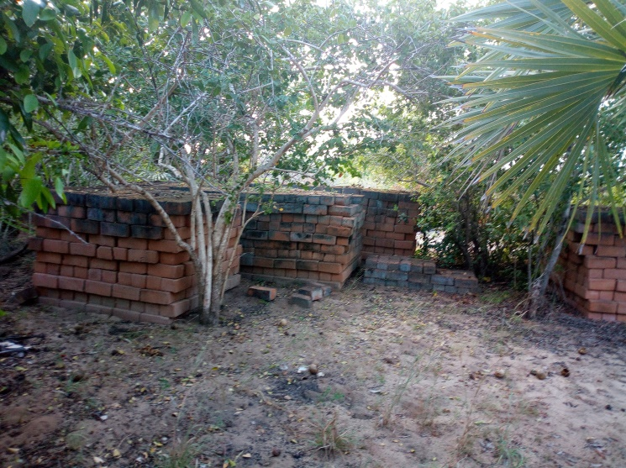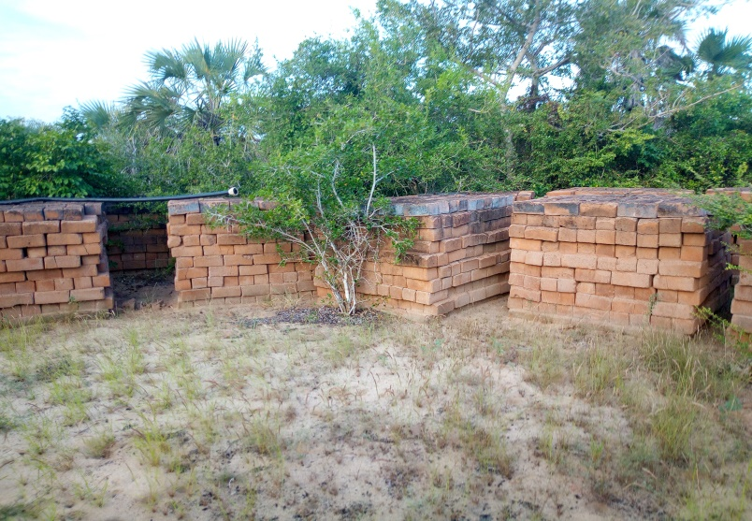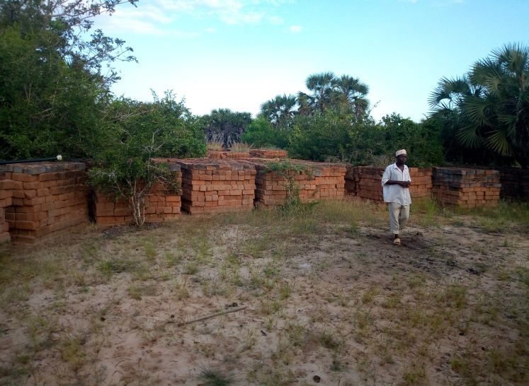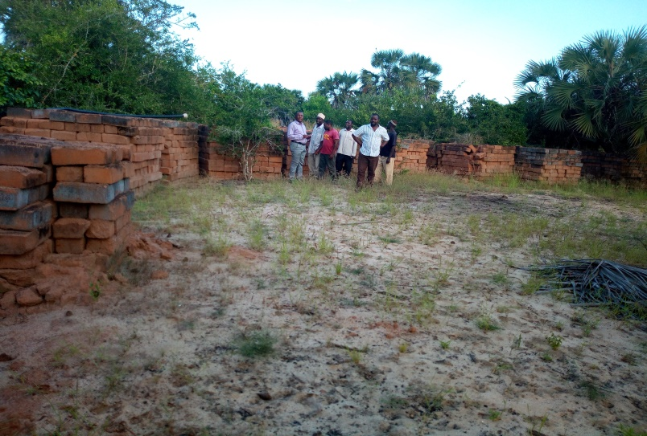
Figure 12: Bricks Factory at Uvinje nearby the shore whereas the bricks were expected to build the new hotel (Coco Lodge) but now the goal has remine on paper
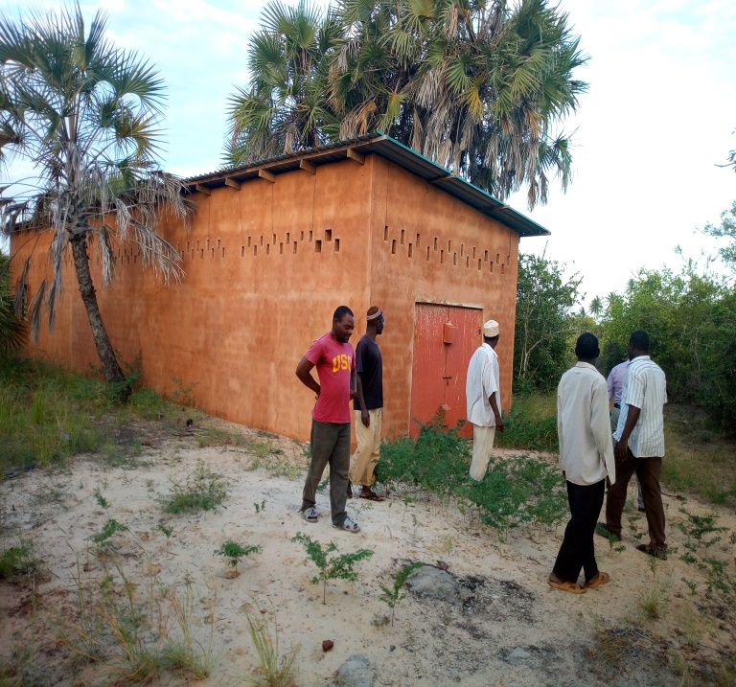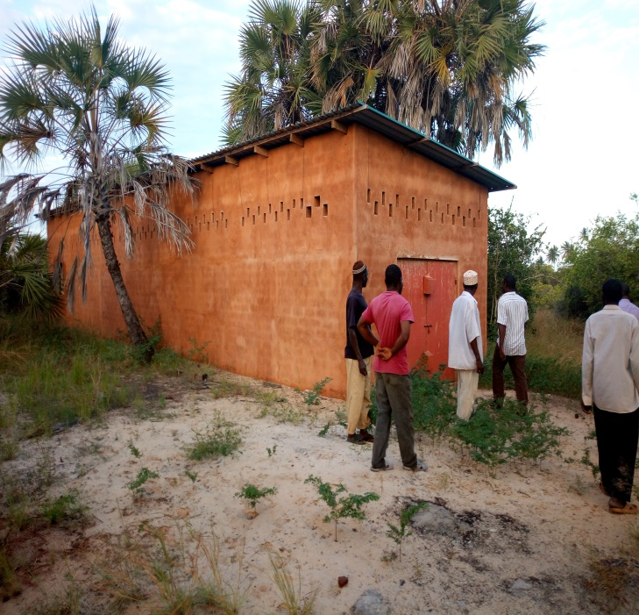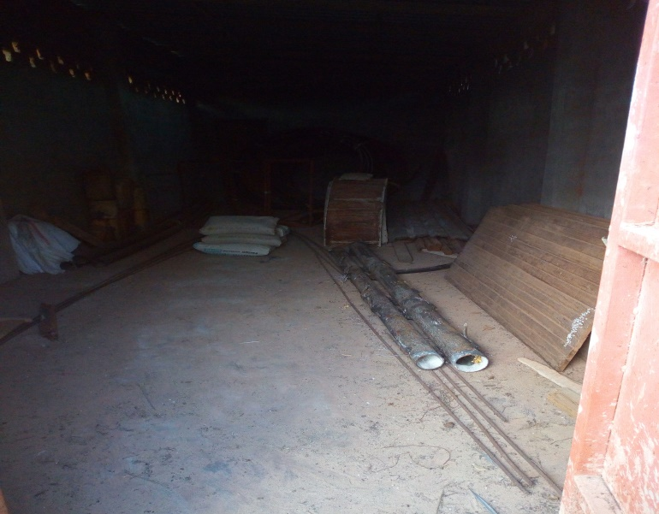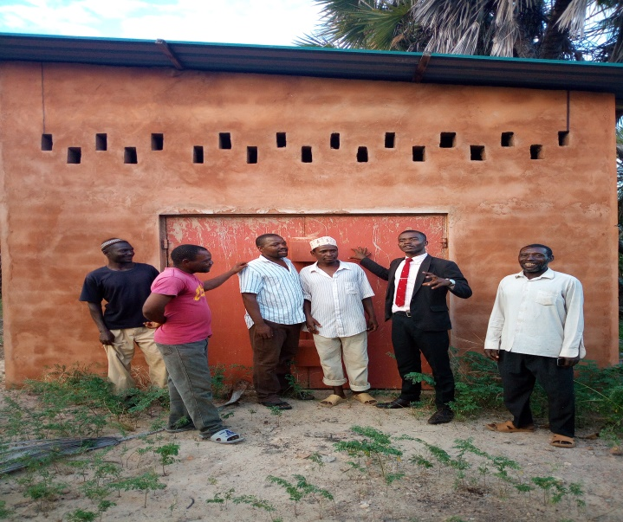
Figure 13: The warehouse made for the hotel investment by the villager but now it has been dominant due to the existing conflict
  - CONCLUSION
Residents of Uvinje sub-village have a number of logic reasons which are enough to defend them why they have not to evacuate the place regardless of the power which the government is using to make sure the commanding power works. It is true that the power used by the government in terms of coercive apparatus, political authority and financial stability weakening the strong spirit of the Uvinje sub-village but still they have survived for all those years more than decade. Since nature of their dispute is legally based, LHRC is appealing to national and International legal entities to intervene and provide support to the Uvinje sub-village so that to make sure together we protect the minority underprivileged section of Saadan Village in this place. This will go together with the sending message to the rulers that rule of law and principles of humanity and dignity have to be adhered, respected and promoted by all regardless of our social or economic status and thus the primary obligation of the state is to secure the wellbeing of its people.
Legal and Human Rights Centre (LHRC) is expecting fruitful reaction from International organizations as this report will be used to compile the brief report of Protimos as requested.

‘For A Just and Equitable Society’

The Legal and Human Rights Centre (LHRC) is a private, autonomous, voluntary, Non-Governmental, non-partisan and non-profit sharing organization envisioning a just and equitable society. It has a mission of empowering the people of Tanzania, so as to promote, reinforce and safeguard human rights and good governance in the country. The broad objective is to create legal and human rights awareness among the public and in particular the underprivileged section of the society through legal and civic education, advocacy linked with legal aid provision, research and human rights monitoring.
United Kingdom (based) Legal charity.
Saadani Game Reserve
ICCA CONSORTIUM documents on Uvinje-Saadan dispute
Saadani National Park
The Constitution of the United Republic of Tanzania (1977) as amended time to time

